

VPC PEERING

L. SAI DEEPTHI

[saideepthilanka6950@gmail.com](mailto:saideepthilanka6950@gmail.com)

Batch:122

Date:11/04/2024

Create two VPC’s in different regions and connect the two VPC’s

1. Open AWS console and first select one region as Singapore then create a VPC named as singapore vpc and IPv4 CIDR as 100.0.0.0/16.

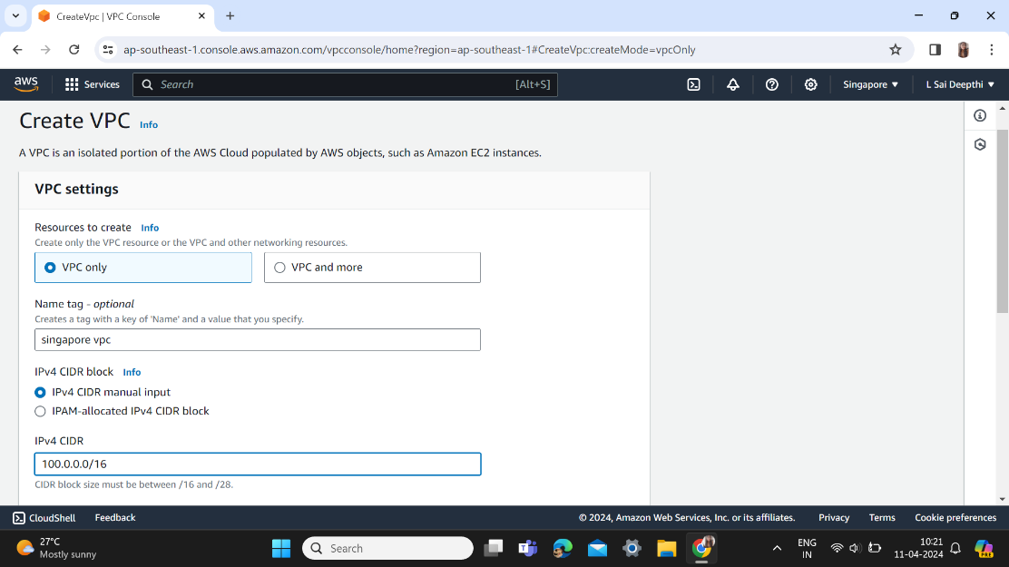

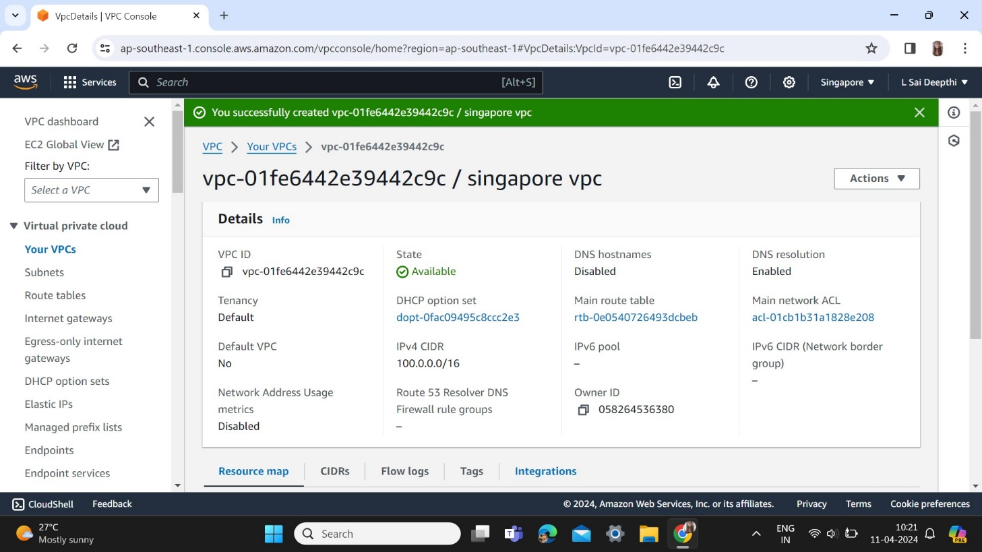

Create a subnet named as singapore subnet with CIDR 100.0.0.0/24.

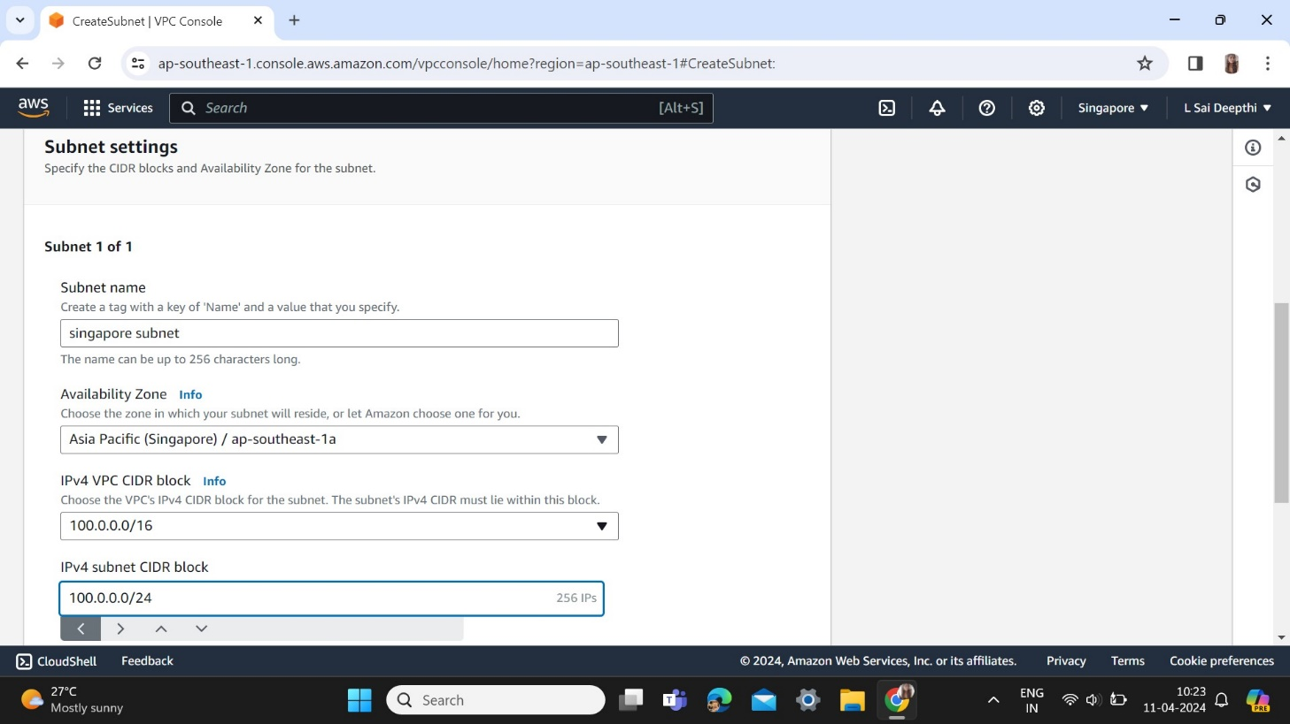

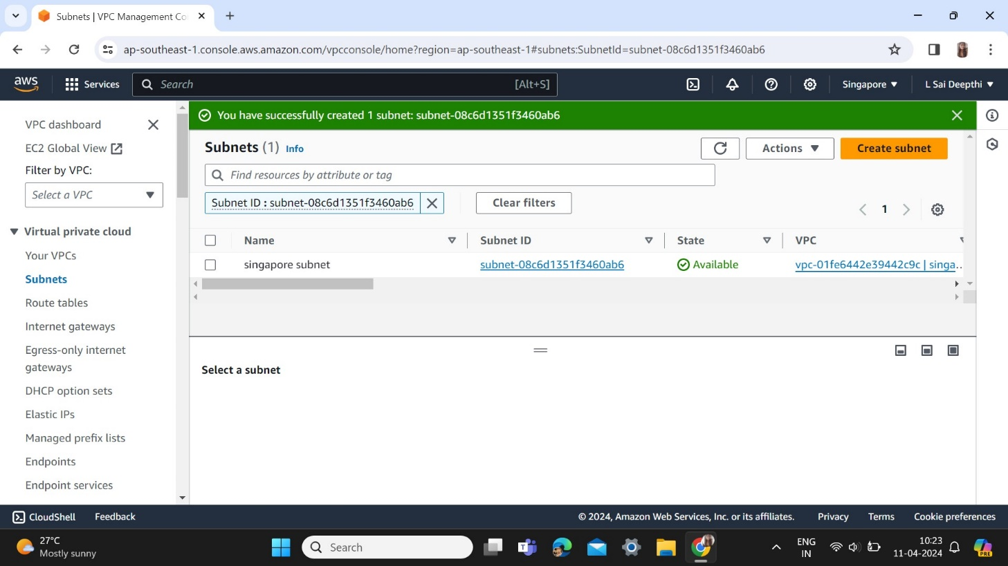

Create a internet gateway named as singapore igw

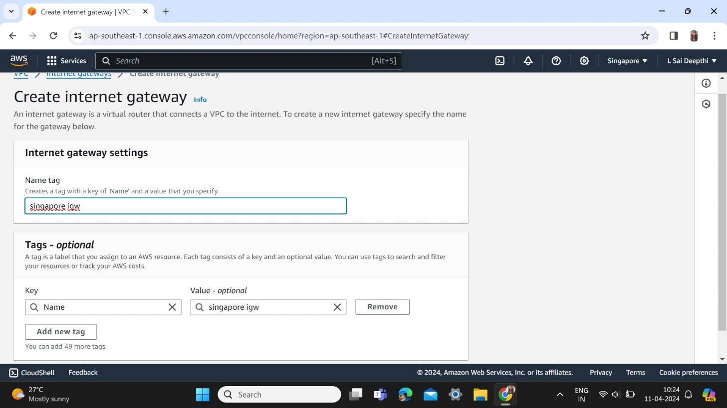

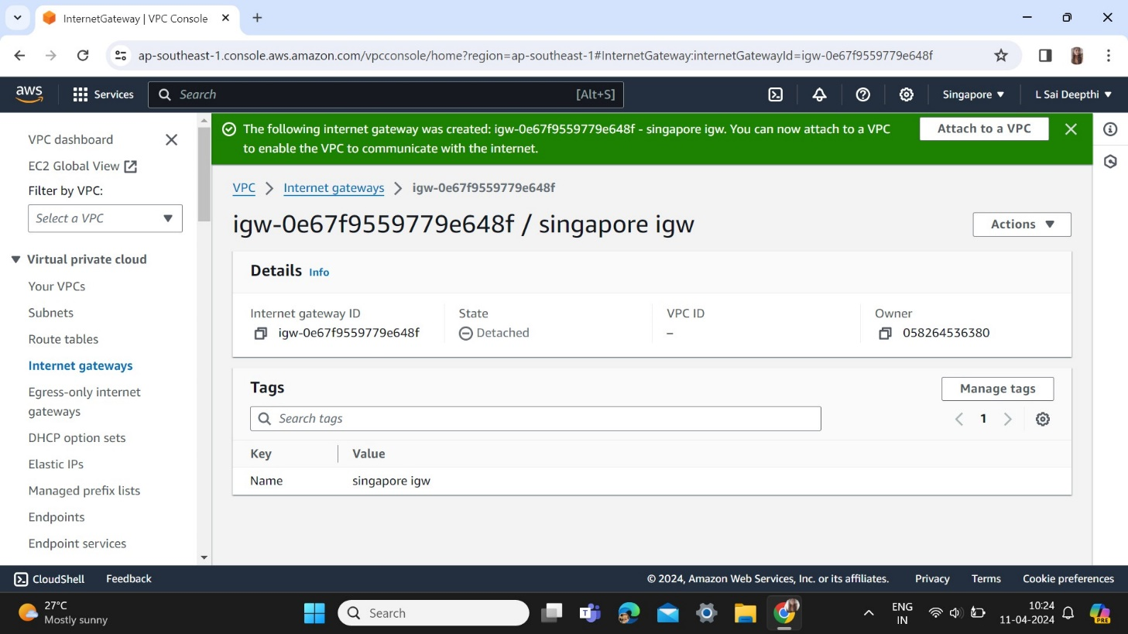

Attach to a VPC

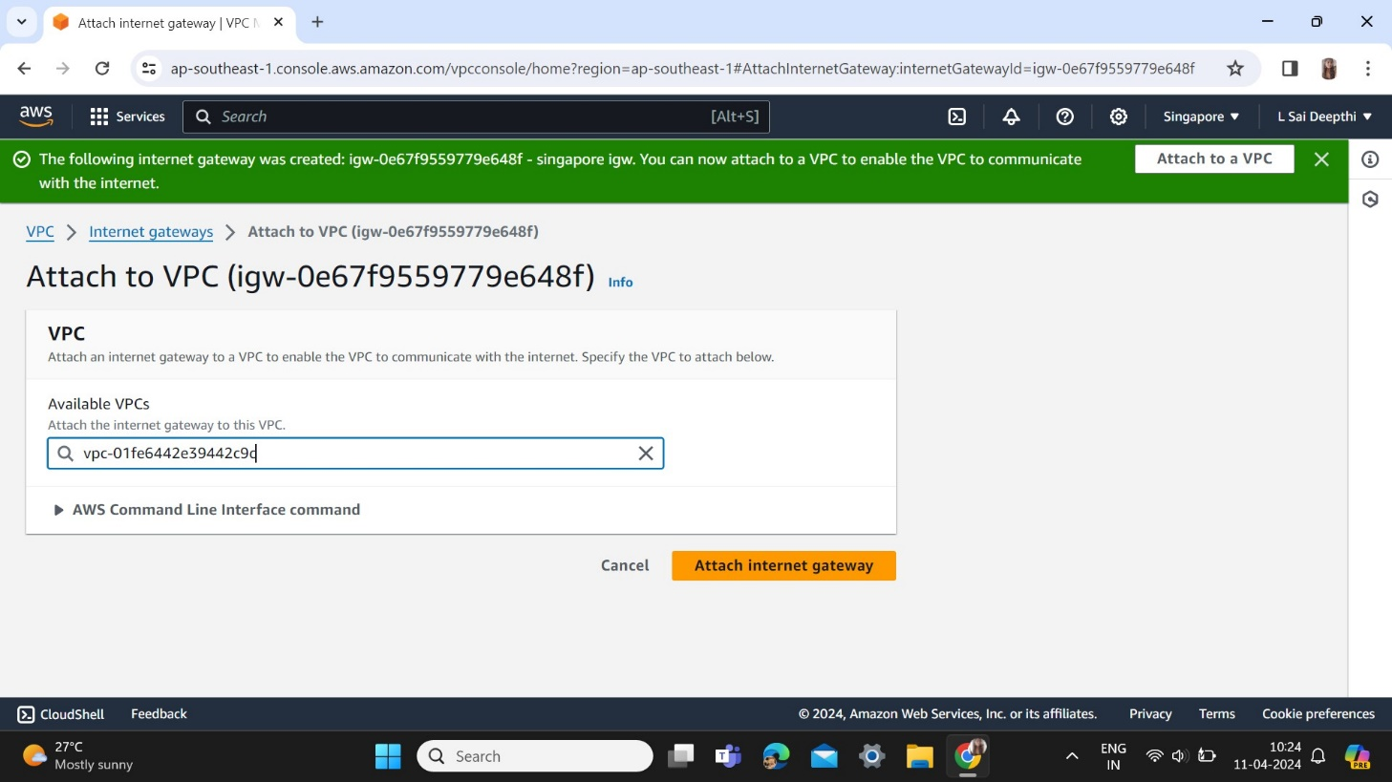

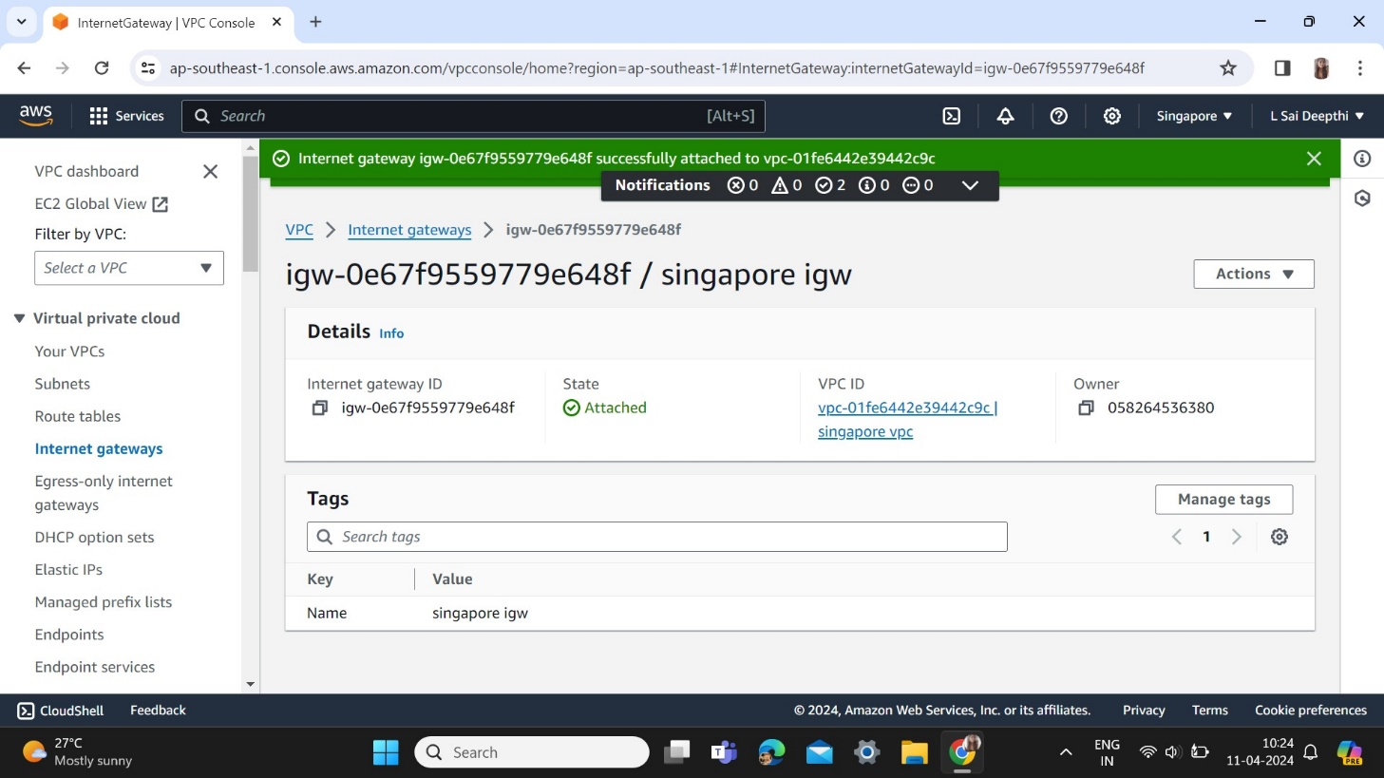

Create a Route Table as singapore routetable

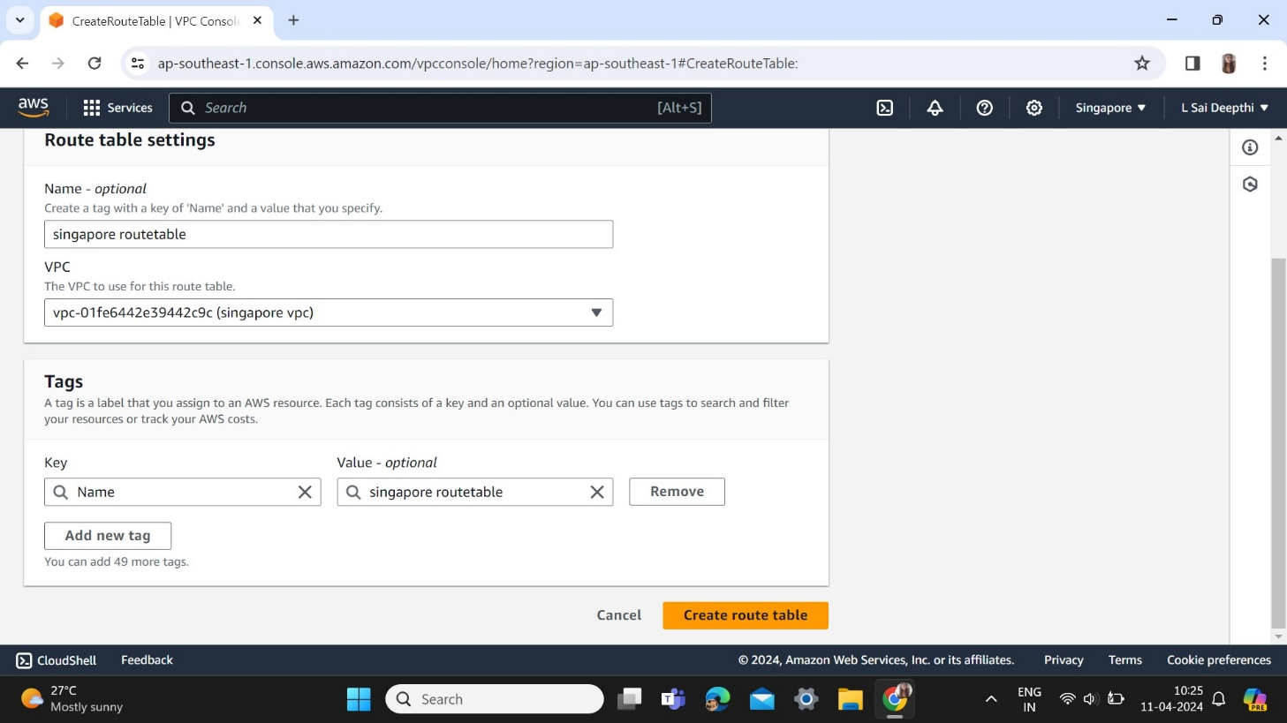

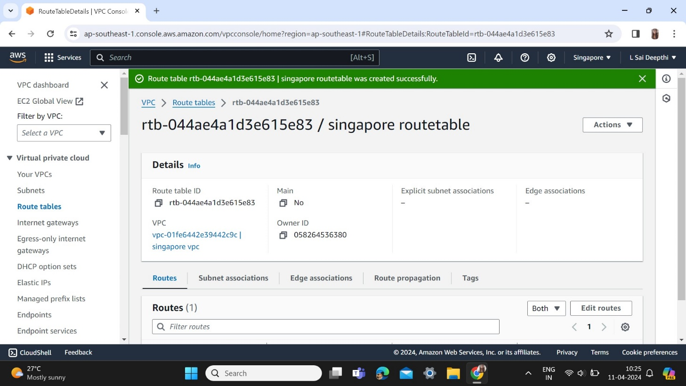

Edit routes keeping target as internet gateway

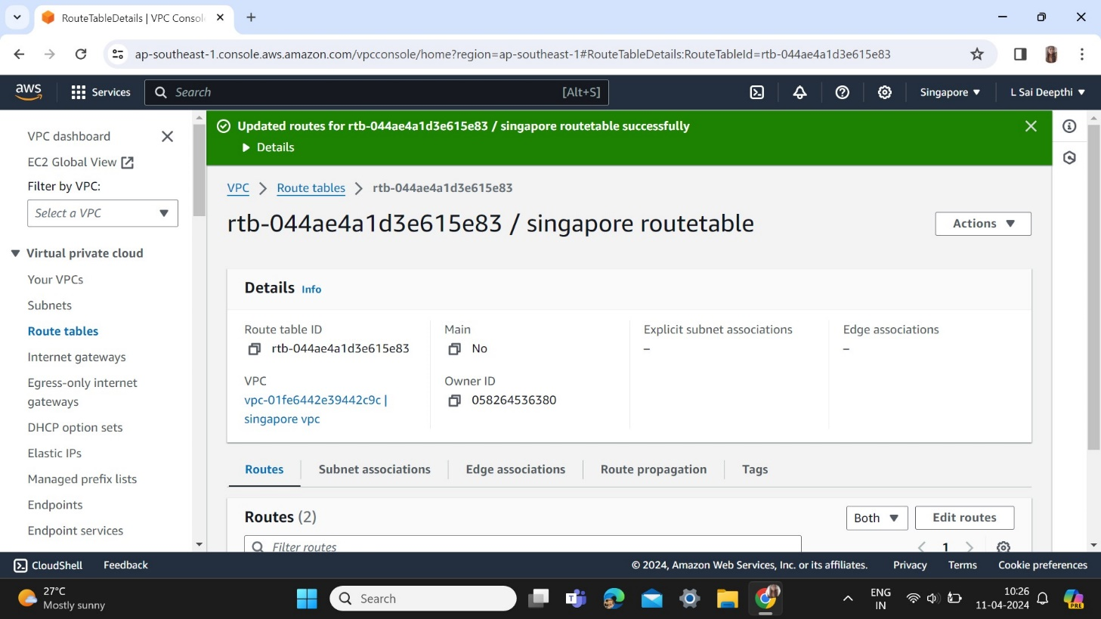

Create EC2 instance and add keypair and launch an instance

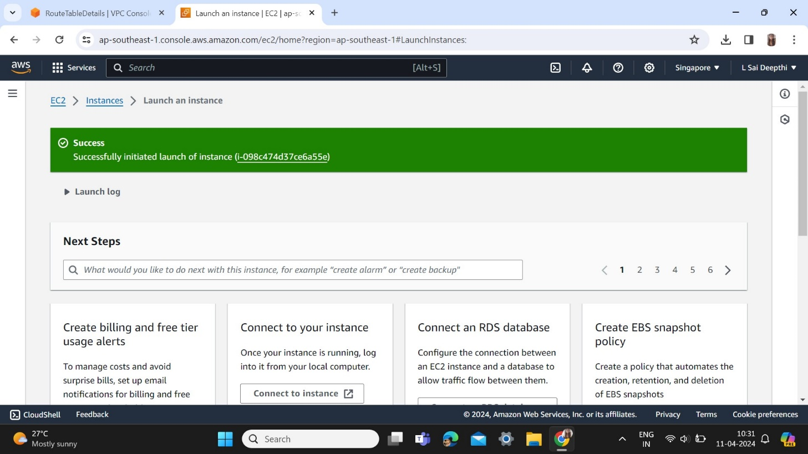

Edit inbound rules

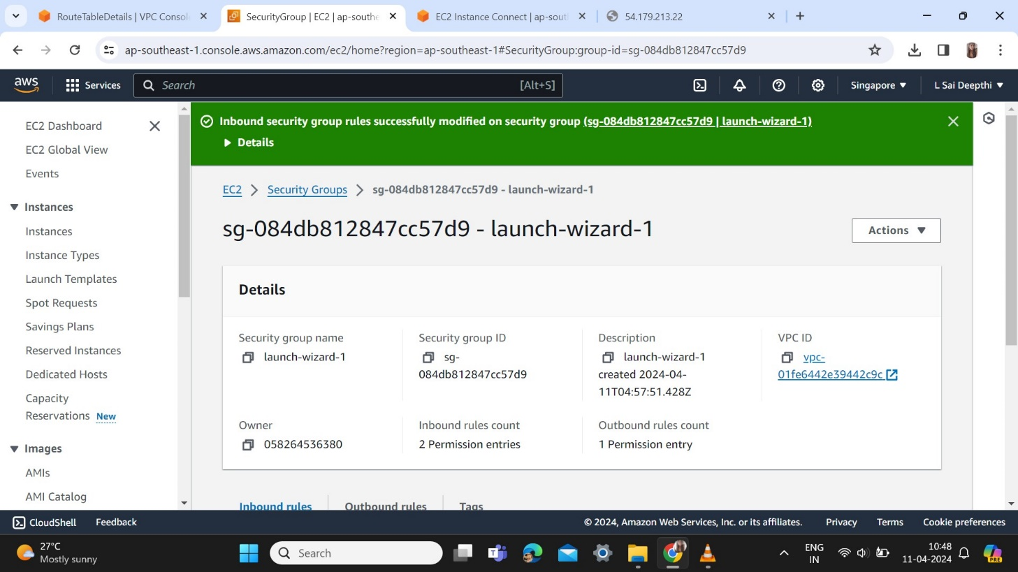

1. Create VPC in second region Central Canada named as canada vpc

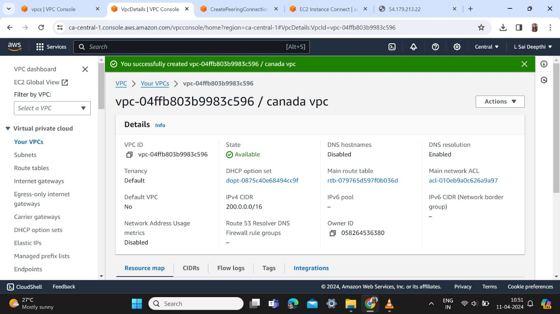

Create a subnet named as canada subnet

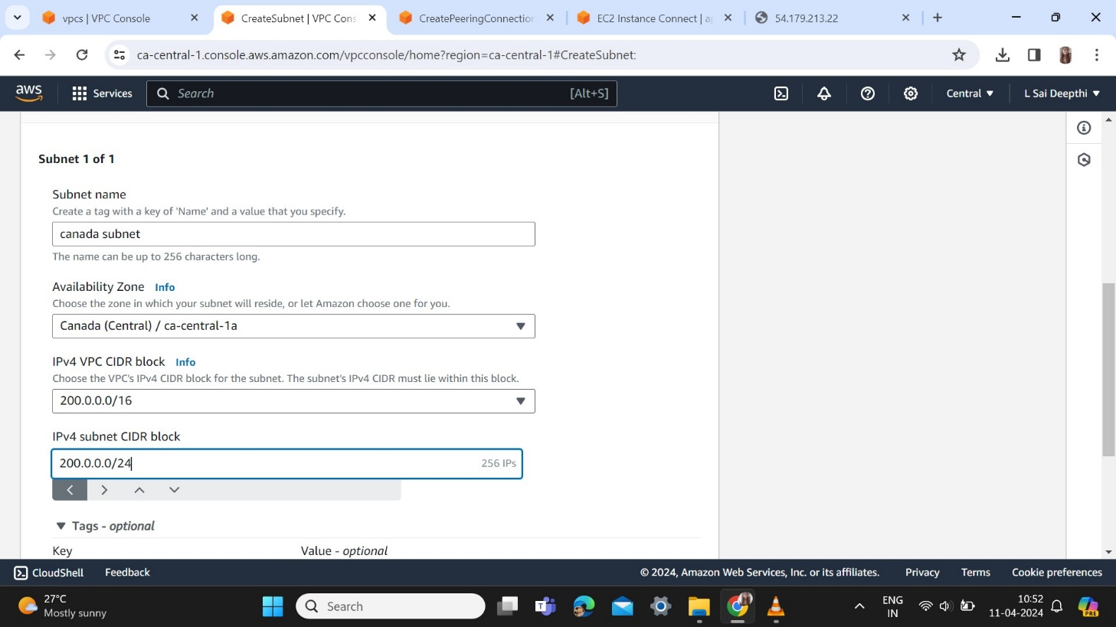

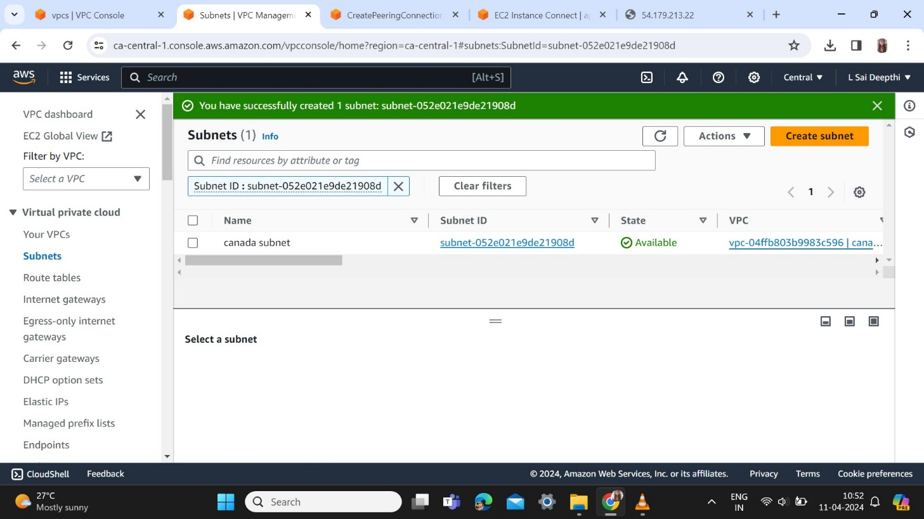

Create a Internet gateway named as canada igw

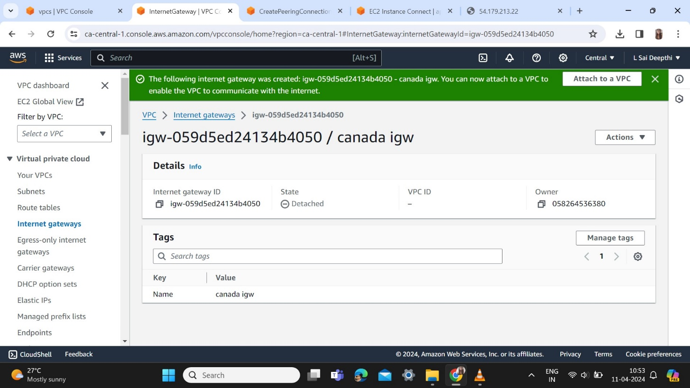

Attach to a VPC

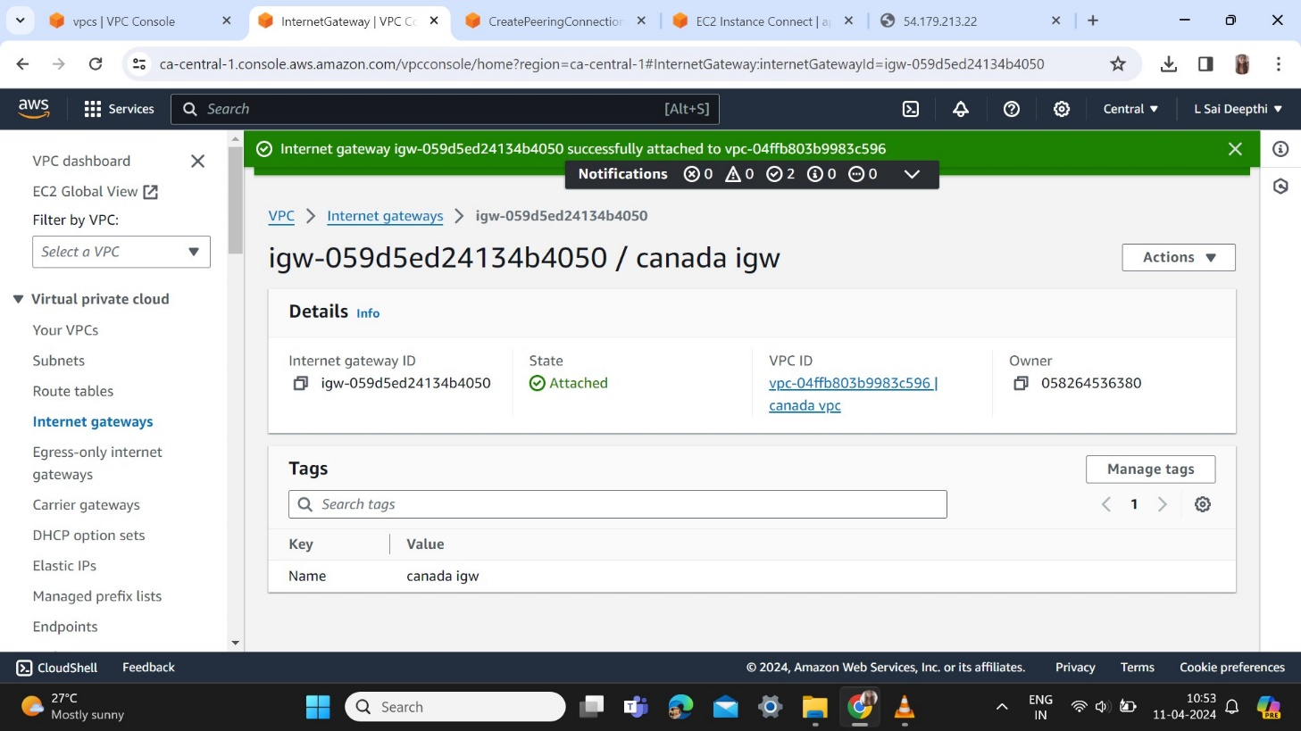

Create a Route Table named as canada routetable

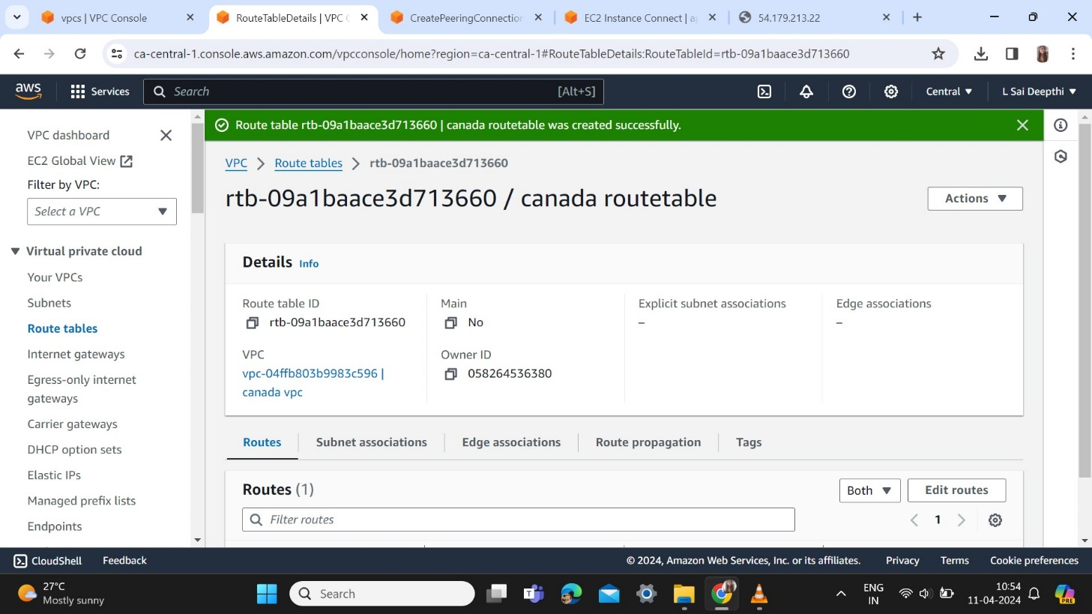

Edit routes keeping target as internet gateway

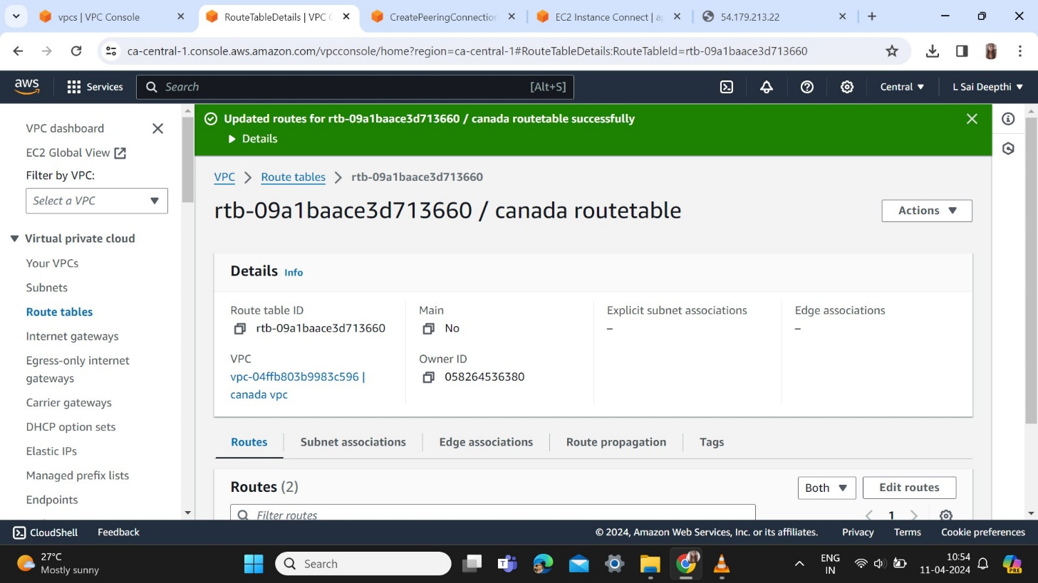

Edit Subnet associations

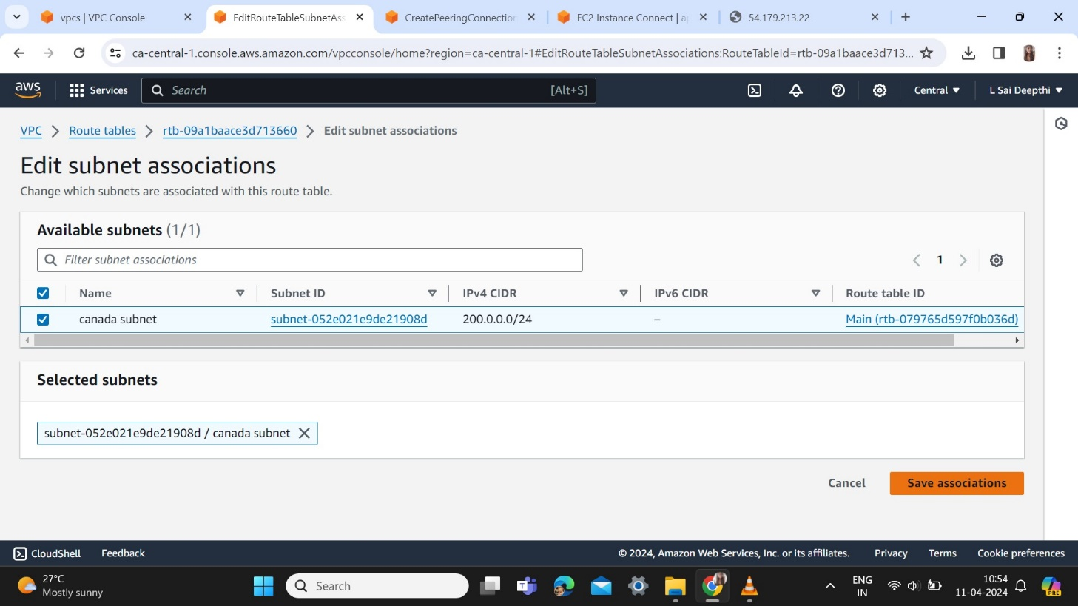

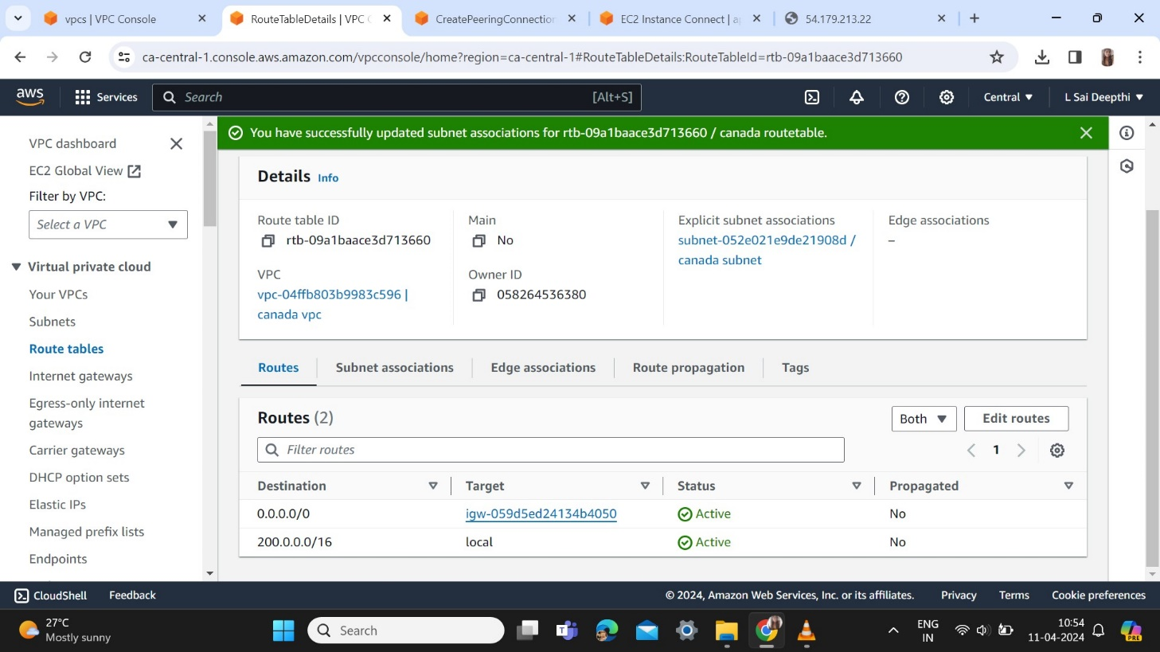

Create EC2 instance with keypair and launch an instance

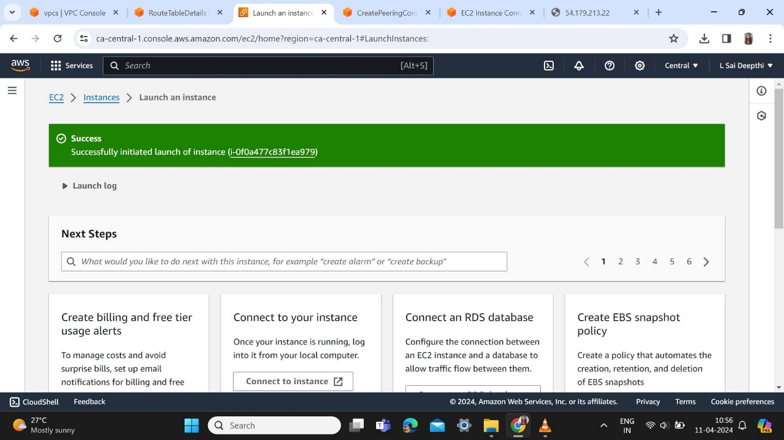

Edit inbound rules

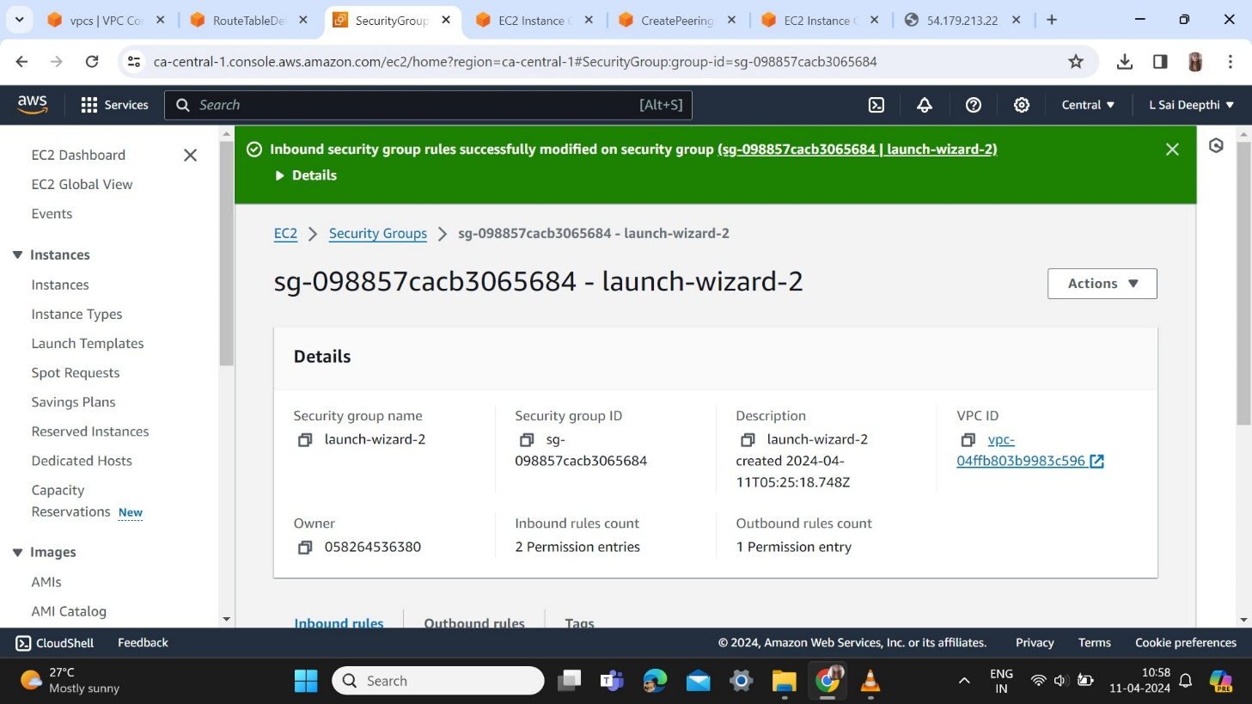

Now create a peering connection in one region Singapore and then accept the connection in another region canada

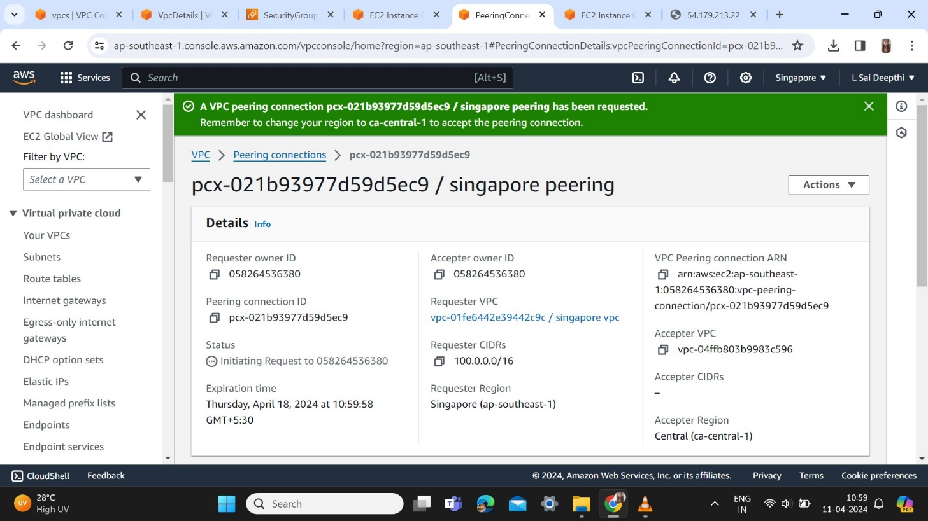

In Singapore region peering connection update and install nginx

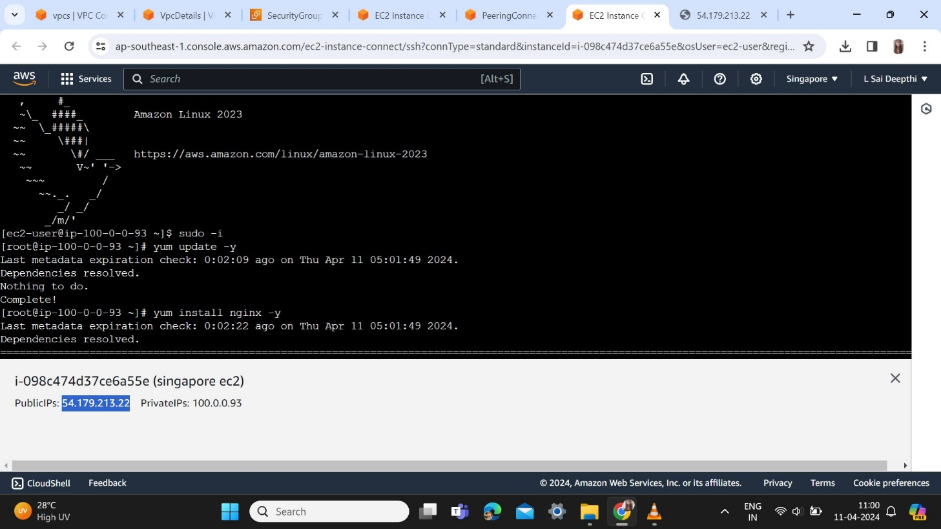

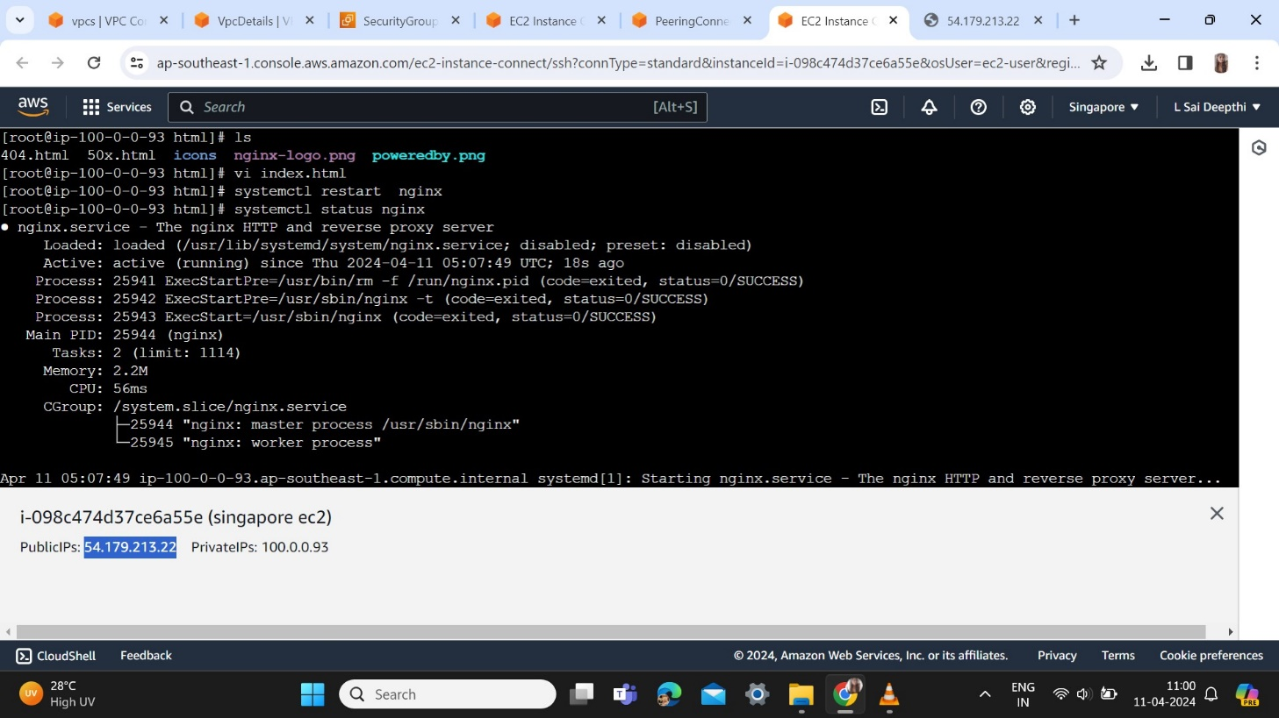

After establishing peering connection modify my route tables

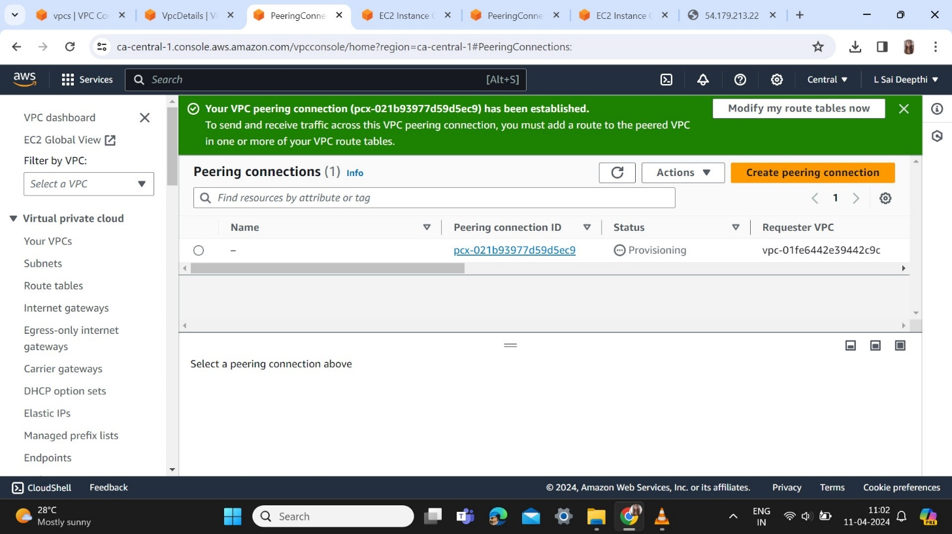

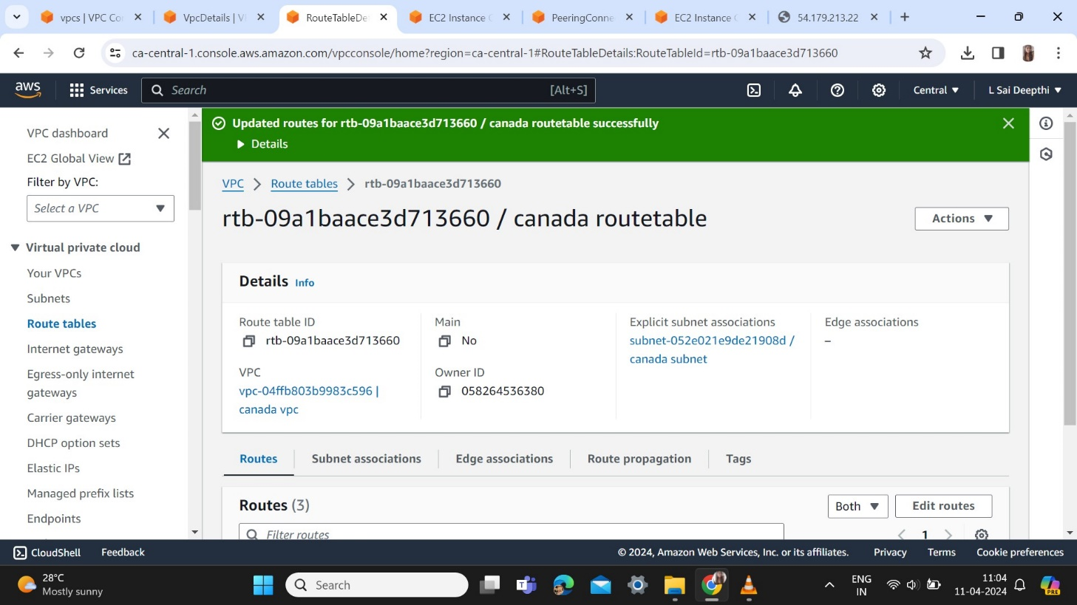

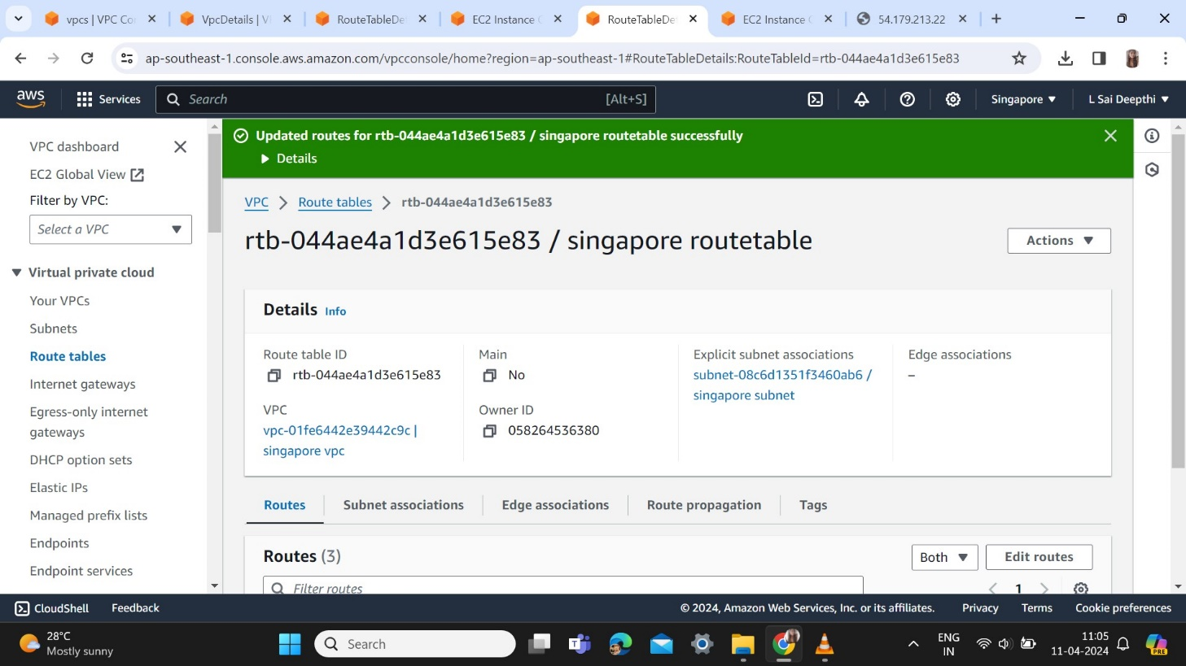

Checking with the private ip address of Singapore region in Central Canada we will get the connection

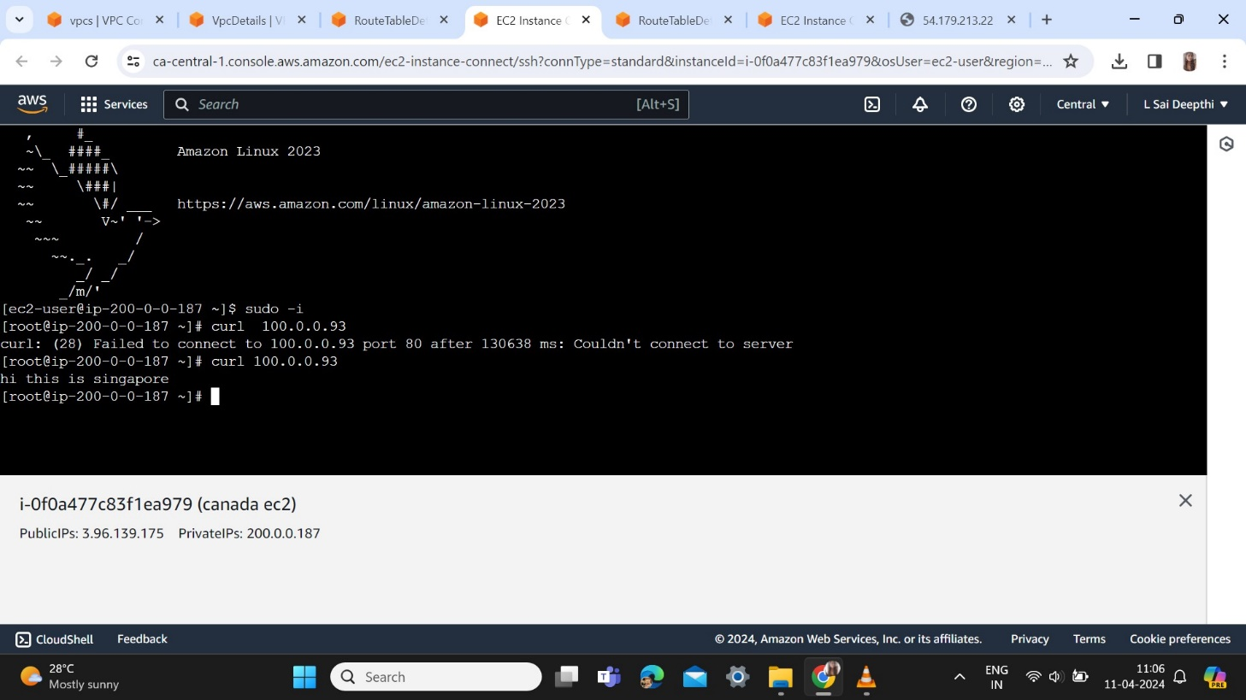

The connection between two different has been established using VPC Peering.